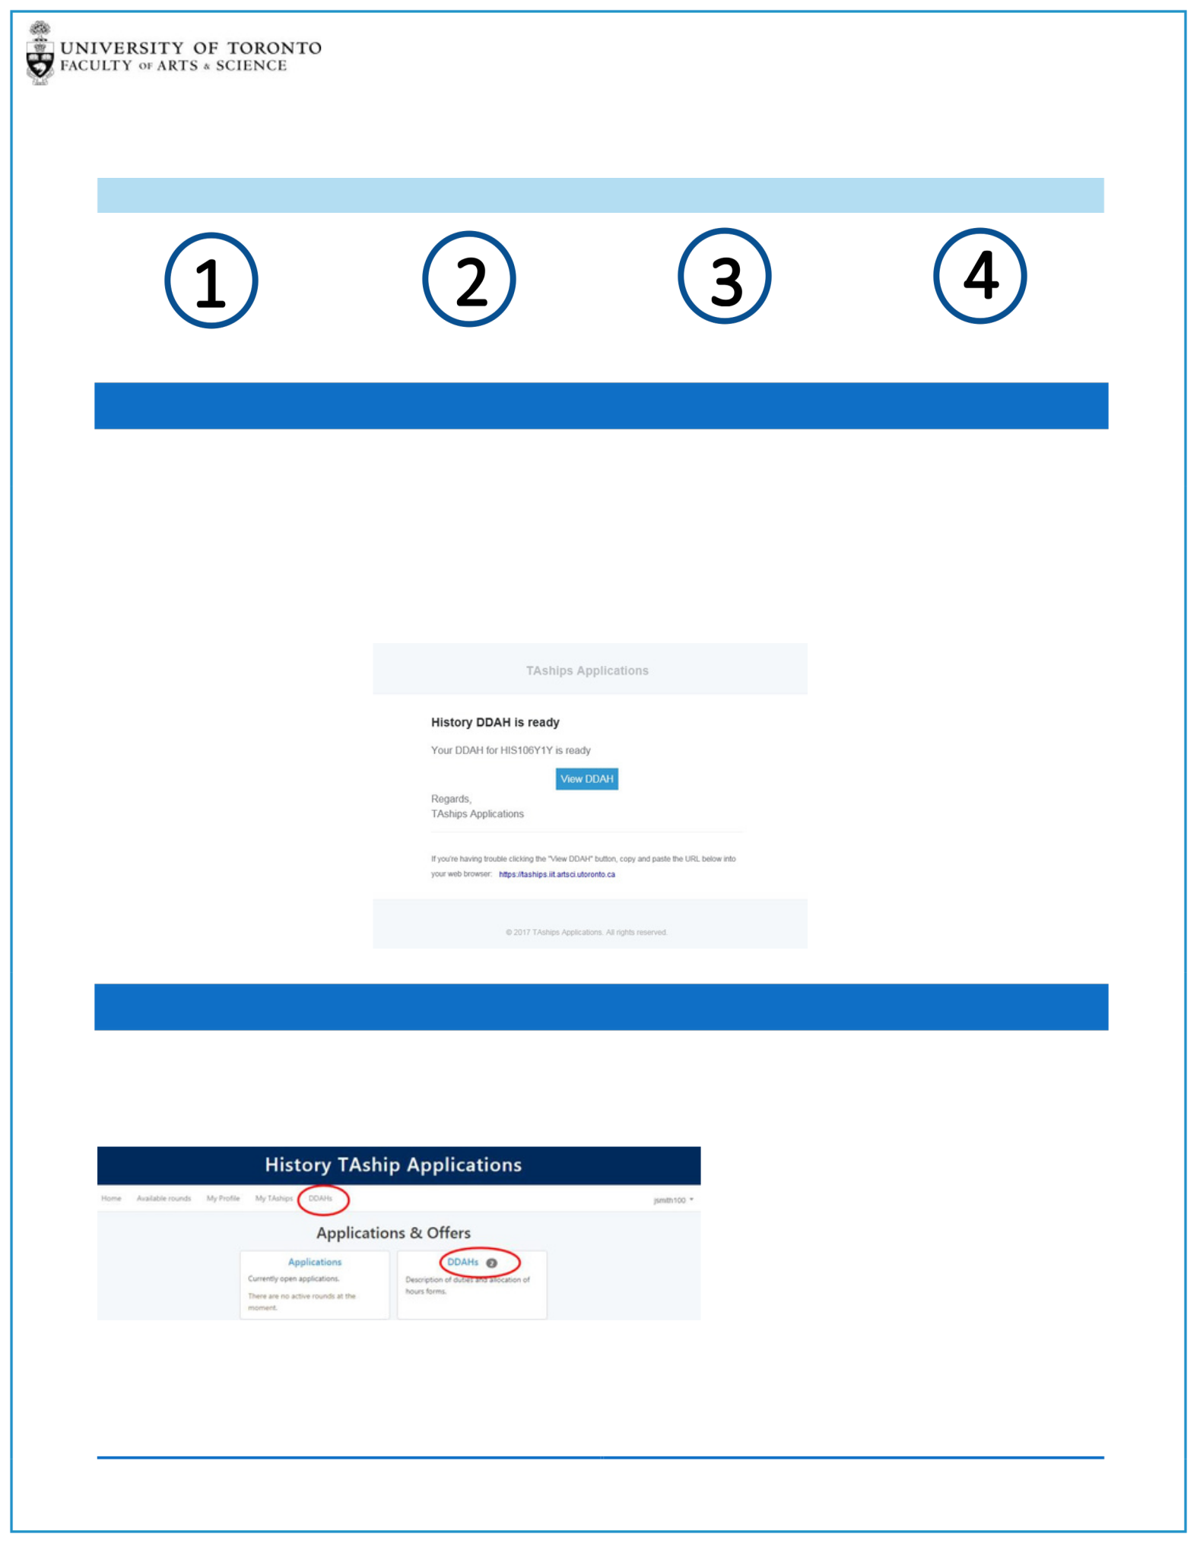ONLINE DDAH

TIP SHEET FOR TEACHING ASSISTANTS

Receive Email Log onto System Review DDAH Acknowledge DDAH

STEP 1: RECEIVE EMAIL

Departments within the Faculty of Arts & Science are moving the DDAH process online. Instructors will now create DDAH forms online while the TAs will be able to review the completed DDAHs online.

After the Instructor has completed the DDAH form the TAShip System will send you an email notifying

you that your DDAH is ready for your review. Clicking on the View DDAH button will take you to the TAShip System

STEP 2: LOG ONTO SYSTEM

Log onto the system with your UTOR ID and you will see a new DDAH option on your landing page.

*In the example below the TA has 2 DDAH forms in the system for this active session.*

After clicking on the DDAH link, you will be taken to the DDAH page where you will see a list of DDAH forms and their status for the active Session.

ONLINE DDAH - TEACHING ASSISTANT TIP SHEET 1

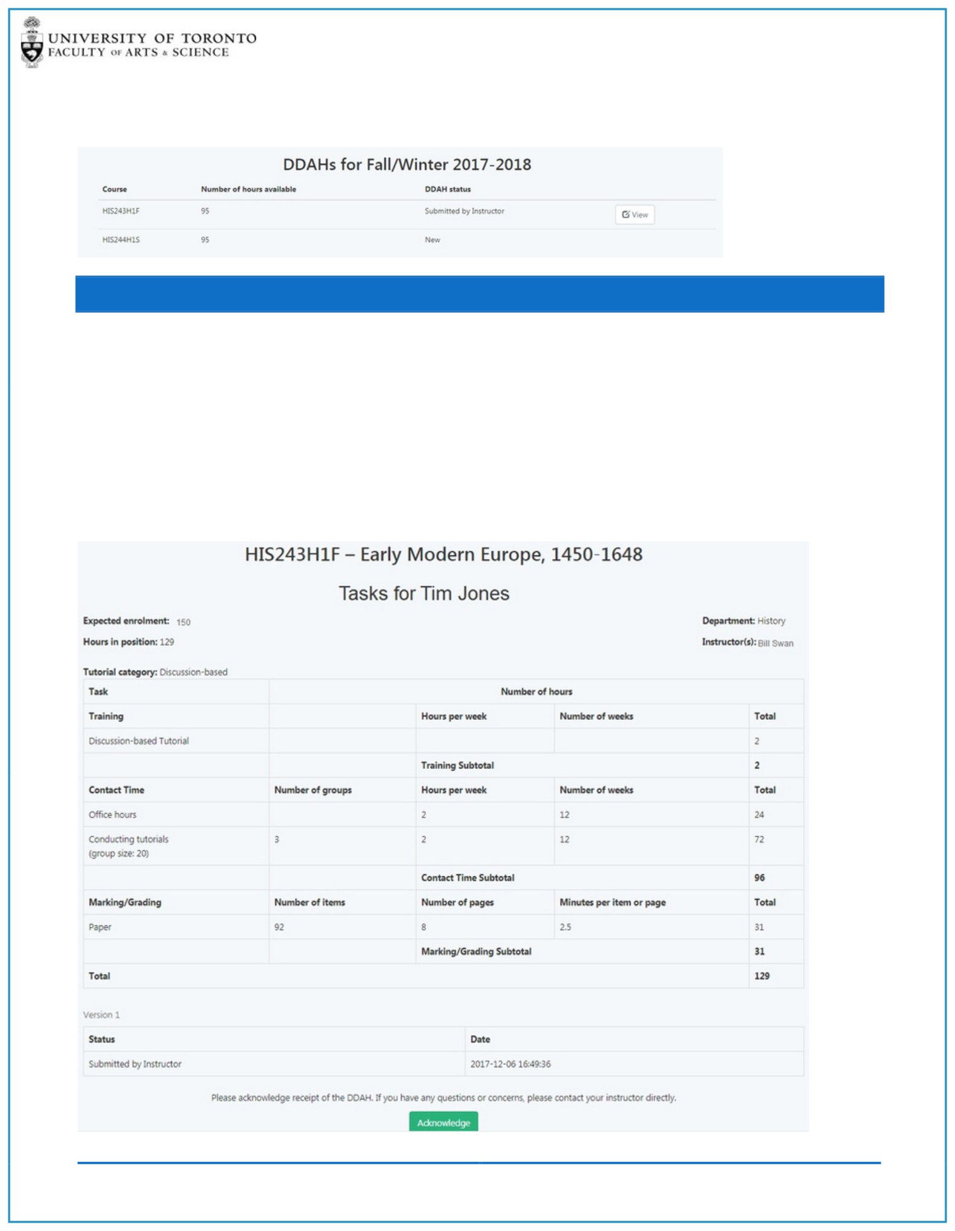You will only be able to view completed DDAH forms that have been submitted by the Instructor.

*In the example below only one of the DDAHs is ready for the TA to view*

STEP 3: REVIEW DDAH

The DDAH form will display the following information:

Course Code Course Name TA Name

Department

Instructor Name

Expected Enrolment *(if entered by Dep’t)*

Tutorial Category *(if entered by Dep’t)*

Hours in Position and Total Hours

DDAH Task Names and Hours *(grouped by category)* DDAH Task Descriptions *(underneath Task Name)*

DDAH Version and Status

|  |  |
| --- | --- |
| ONLINE DDAH - TEACHING ASSISTANT TIP SHEET | 2 |

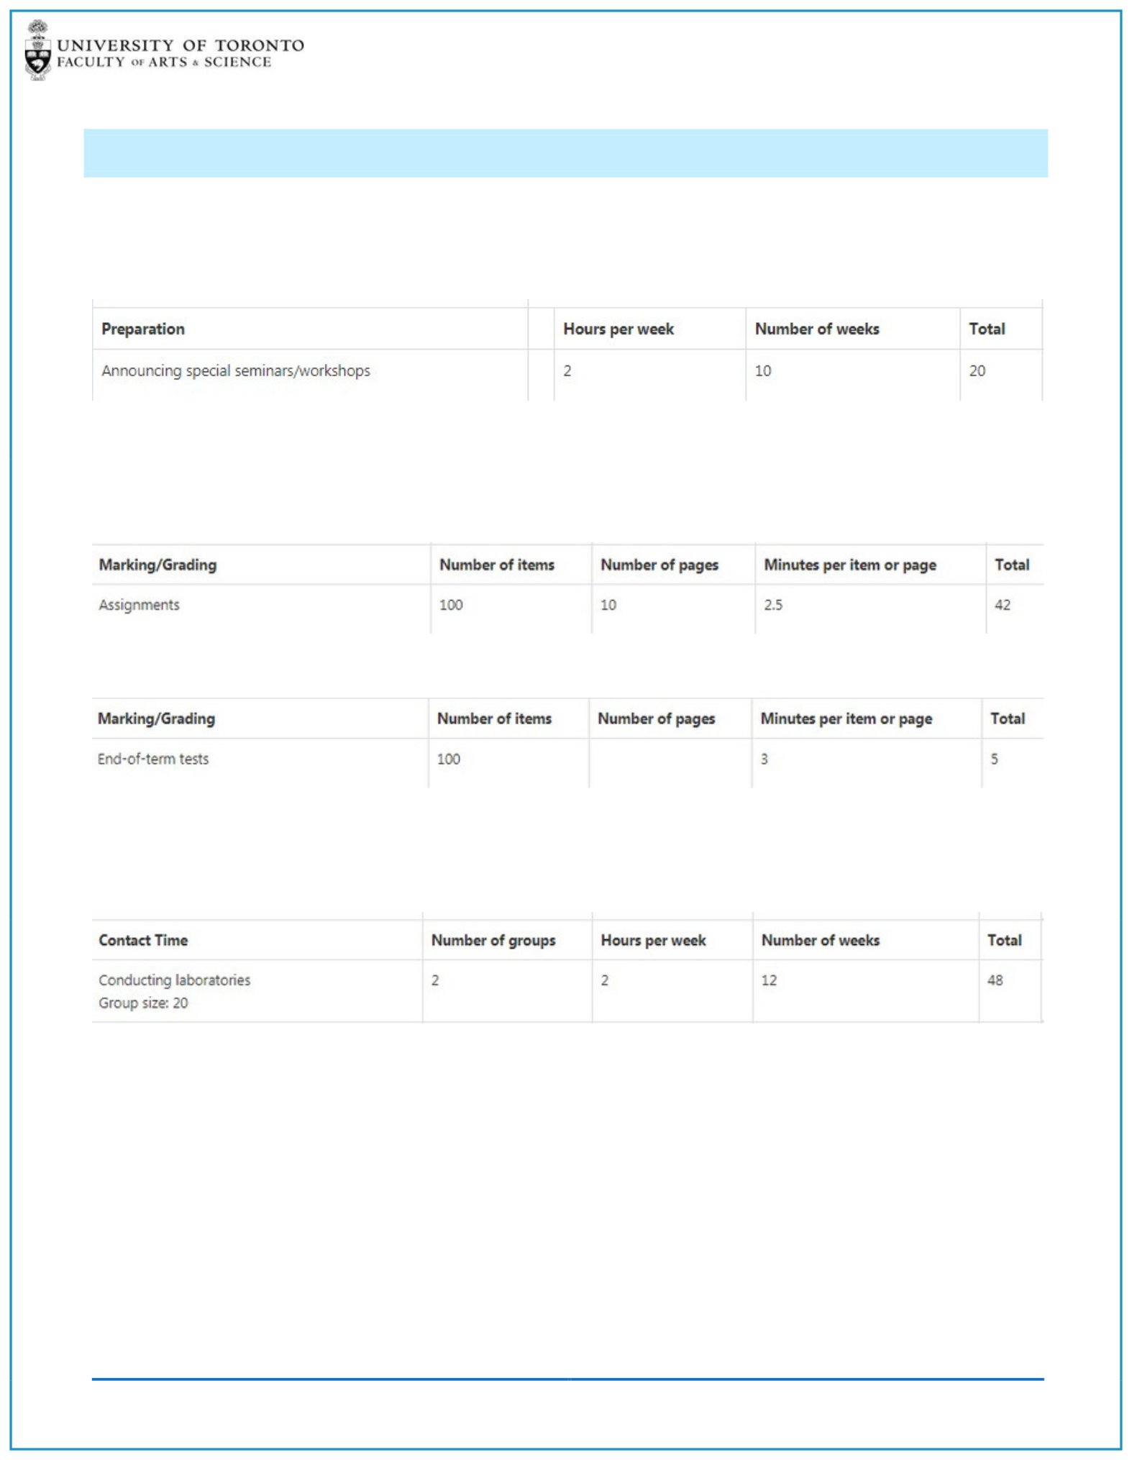

DDAH TASKS CAN BE BROKEN DOWN AS FOLLOWS:

WEEKLY TASKS

Where applicable *weekly tasks* will be broken down into Hours per Week and Number of Weeks

MARKING TASKS

Where applicable *marking tasks* will be broken down into either:

Number of Items X Number of Pages X Minutes per Page

Number of Items X Minutes per Item

GROUP TASKS

Where applicable *group tasks* will be broken down into Number of Groups X Hours per Week X Number of Weeks. The Group size will be included in the task description.

ONLINE DDAH - TEACHING ASSISTANT TIP SHEET 3

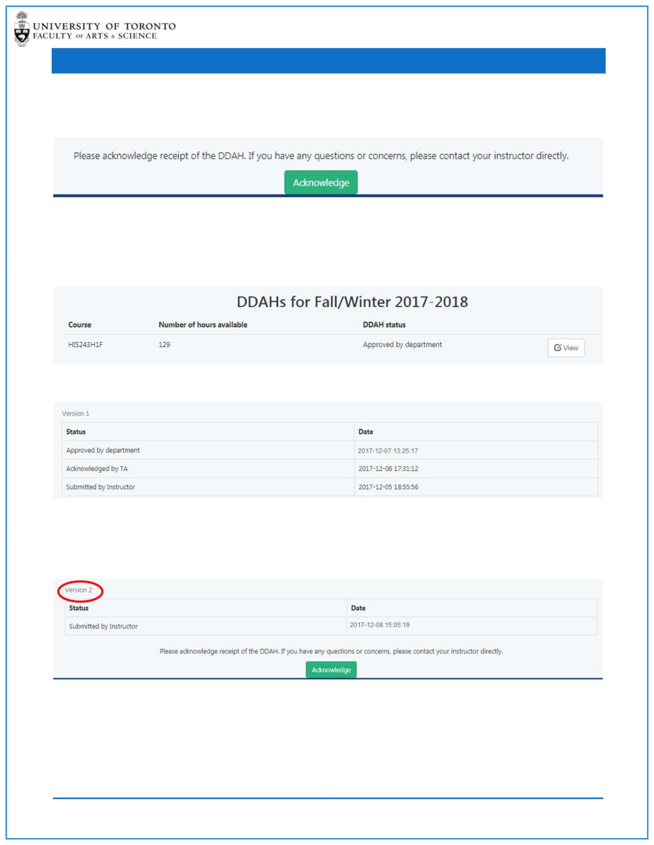STEP 4: ACKNOWLEDGE DDAH

After you have reviewed your online DDAH you should click on the Acknowledge button.

*PLEASE NOTE: If you have any issues or questions you should contact your Instructor directly.*

After you have Acknowledged your DDAH the Department will approve the DDAH.

You can continue to track the status of your DDAH within the system.

From within the DDAH form at the bottom of the screen you can track all status changes:

If your Instructor makes any changes to the completed DDAH a new version will be created and you will be able to review and acknowledge the new version.

ONLINE DDAH - TEACHING ASSISTANT TIP SHEET 4